The influence of contractors in the decision-making process varies based on the type of contract

Rotterdam, June 11, 2021 – When thinking about building materials and product and brand specification, we generally focus on architects and/ or engineers. It is not usual that architects and engineers work for a main contractor. However, the increasing number of design-build contracts and developer contractors, the type of contractors who are appointed to develop and carry out the full project cycle, enables a more integrated value chain. This becomes apparent in the H2 2020 report of USP Marketing Consultancy’s European Contractor Monitor.

Developer contractors work more with design-build contracts
Contractors see themselves as most influential in product and brand choice. Overall, more than 50% of the contractors have a say in the design process, and more than 80% have the power to influence product or brand specifications. The increasing number of developer contractors enables a more integrated value chain which empowers the contractor even more in the decision-making process.

Developer contractors are more likely to organise different services of a project within their organisation (e.g. architectural, engineering) and work with design-build contracts rather than with traditional contracts. Consequently, developer contractors are more influential, especially in the design process but also in material and brand choice, than non-developers.

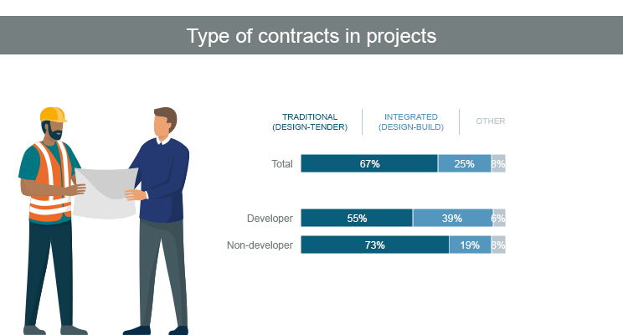

European Contractor Monitor Q1 2021 – USP Marketing Consultancy

They are also more empowered
As can be seen in the image below, developer contractors are indeed more influential in the final decision making than non-developers. They have in fact greater influence in all parts of the process. But mostly they are end-decision makers in brand and product choice. Non-developers are more often co-decision maker in these phases.

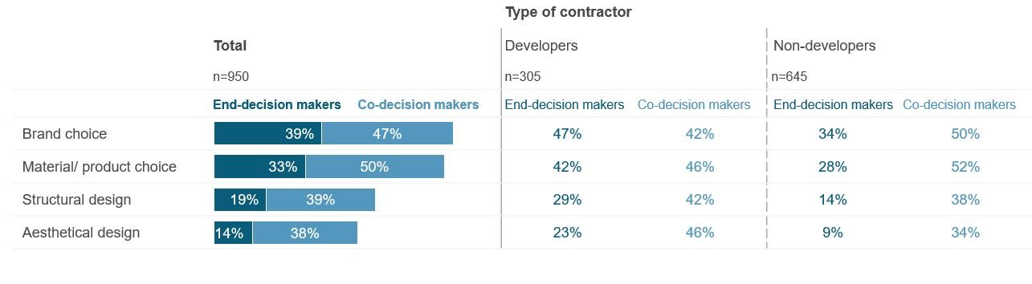

European Contractor Monitor Q1 2021 – USP Marketing Consultancy

Knowing the DMU is the key to success
Overall trends, like a more integrated value chain structure and increasing amounts of design-build contracts, cause the DMU of the construction sector to evolve. To optimise effectiveness of marketing strategies, manufacturers need to keep up to date with how these trends affect the role of the key stakeholders in the construction process to be sure to target the right people.

For more information on trends affecting the DMU in the construction sector, we refer you to the H2 2020 report of USP Marketing Consultancy’s European Contractor Monitor.

About USP Marketing Consultancy
USP Marketing Consultancy is a leading international market research agency that is specialized in the construction, installation and DIY sector for over 25 years. USP Marketing Consultancy works for internationally renowned companies, such as AkzoNobel, Philips, Grohe, Forbo, etc. Our clients often have pan-European questions about their brand awareness, customer journeys, market opportunities, e-commerce trends and other research needs. USP Marketing Consultancy delivers the insights to make decisions and acts as a marketing advisor for its clients.

Note for editors
For more information or a high resolution image please contact Dirk Hoogenboom of USP Marketing Consultancy, call +31 6 52098924 or mail to Hoogenboom@usp-mc.nl.

When you publish (parts of) this press release, we would like to receive a copy. Please send it to:
USP Marketing Consultancy
Dirk Hoogenboom
Max Euwelaan 51
3062 MA Rotterdam
Hoogenboom@usp-mc.nl

