Sustainability subsidies of the Danish government reach the most consumers

Rotterdam, June 03, 2021 - Due to COVID, consumers were spending more time in the past 12 months. This resulted in increased attention for the house and a large number of home renovations. For several years European governments are trying to motivate homeowners to make their homes more energy-efficient via different subsidies. Until now, Danish consumers used these types of grants the most. About a third of the Danish consumers used this. These are some of the findings of the European Home Improvement Monitor Q1 2021, conducted by USP Marketing Consultancy among consumers in 11 European countries.

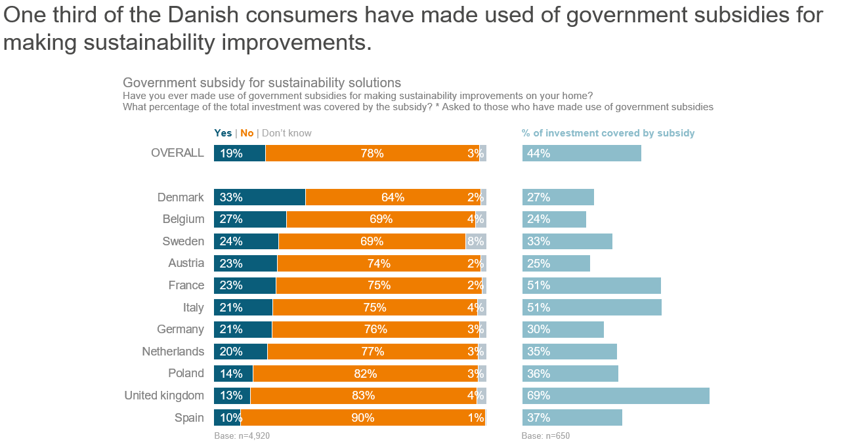
European Home Improvement Monitor 2021 - USP Marketing Consultancy

Consumers in the UK are hard to convince for sustainability improvements
In USP’s Home Improvement Monitor, consumers were asked if they ever made use of government subsidies for making sustainability improvements to their homes. And if so, how much of their total investment was covered by the subsidy? In most European countries, about a quarter of the households ever made use of a government subsidy. In Poland, Spain, and the UK, the share of households using sustainability subsidies is considerably lower. Especially in the UK, this is remarkable as the households that did make use of the government subsidy had a large amount of the investment covered by it (69%). In comparison to Denmark, a third of the consumers used government subsidies while only 27% of their investment in sustainability was covered.

Saving money is the key driver of sustainability
Although protecting the environment and increasing the comfort level of their home are often drivers for sustainability solutions, the key driver is saving money. This is the case in 10 out of the eleven researched countries. The only exception was Austria. Where protecting the environment is the main reason for consumers for improving the sustainability level of their home.
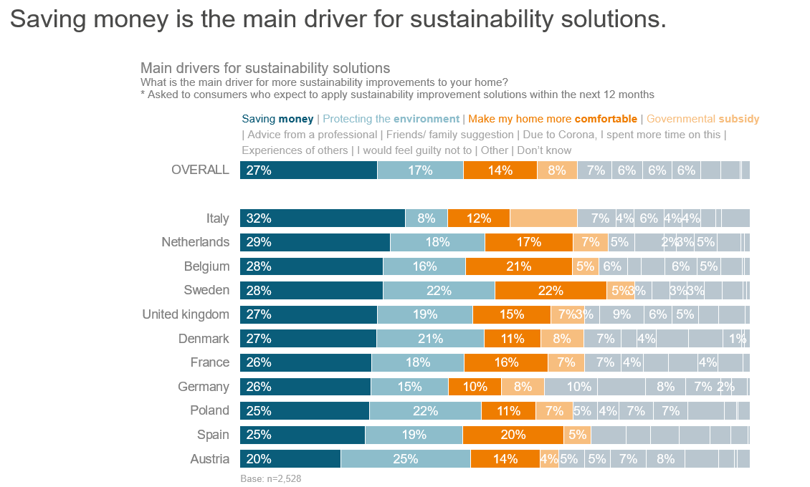

Plans for more sustainability improvements at home
The European households still have the interest to take further actions to improve their homes' sustainability level the majority of the households plan for additional sustainability solutions in their house within the next 12 months. The highest on their wish list are solar panels (20%), water-saving taps (19%), and optimizing the insulation of their home (18%). Also, a significant part is looking for smart home solutions to save energy (16%).
About USP Marketing Consultancy
USP Marketing Consultancy is a leading international market research agency that is specialized in the construction, installation and DIY sector for over 25 years. USP Marketing Consultancy works for internationally renowned companies, such as AkzoNobel, Philips, Grohe, Forbo, etc. Our clients often have pan-European questions about their brand awareness, customer journeys, market opportunities, e-commerce trends and other research needs. USP Marketing Consultancy delivers the insights to make decisions and acts as a marketing advisor for its clients.

Note for editors
For more information or a high resolution image please contact Dirk Hoogenboom of USP Marketing Consultancy, call +31 6 52098924 or mail to Hoogenboom@usp-mc.nl.
When you publish (parts of) this press release, we would like to receive a copy. Please send it to:
USP Marketing Consultancy
Dirk Hoogenboom
Max Euwelaan 51
3062 MA Rotterdam
Hoogenboom@usp-mc.nl

