The construction sector is stabilising, but not everywhere at the same pace

Rotterdam, May 4 2021 – The first lockdown, the one announced in March 2020, had a major impact on the construction sector in many European countries. Projects were postponed and in many countries it took months until the situation stabilized. According to the results of the Q1 2021 report of the European Architectural Barometer, a continual research by USP Marketing Consultancy among architectural firms in eight European countries, most countries have only just returned to the level they were at before the lockdown. Aside from economic developments, this report provides insights in architects’ expectations of trends resulting from the corona pandemic.

March 2020 Lockdown turning point for construction volumes
The lockdown destroyed European architects’ optimism about their order books and expected turnover development. From March 2020, a direct extreme decline of construction volumes compared to the same month in the previous year was apparent especially in Belgium, France, Italy and the UK. This negative development continued in subsequent months. In the Netherlands and Germany, however, developments were more or less stable the entire year. And slowly but steadily, as the year progressed, construction volumes started to rise again in the hard-hit countries. In January 2021, construction volumes in most countries seem to have recovered. Except for in Germany and Poland, construction volumes are at the level they were the year before.

Construction volumes (% change year-over-year)

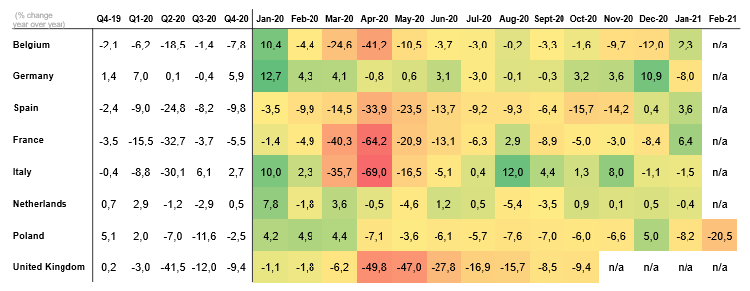

European Architectural Barometer Q1 2021 – USP Marketing Consultancy

Concerning status of building permits, slow recovery expected
Looking at the increased construction volumes in most countries in the last months of 2020, the European construction sector seems to be recovering after the hit in March that year. Most European architects are also experiencing positive developments of their order books. Be that as it may, the corona pandemic has left its mark on the sector, as can be seen in the worrying state of the numbers of issued building permits. In many countries, fewer permits have been issued than in the same period a year earlier, both in residential and non-residential construction. Standing out is Spain, where no improvement can be seen yet. This leaves few reasons to expect a fast recovery of the sector.

Issued building permits non-residential (% change year-over-year)

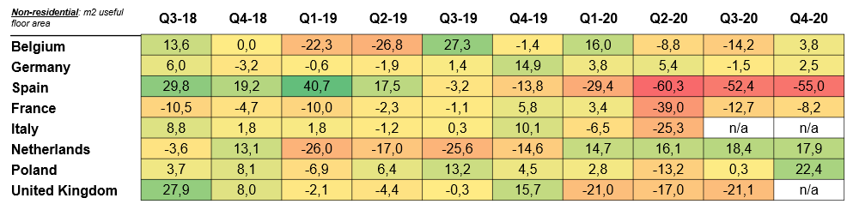

European Architectural Barometer Q1 2021 – USP Marketing Consultancy

Expected developments due to COVID-19
Also interesting to highlight are architects’ expectations of trends caused by the corona pandemic. Architects expect big changes in the types of buildings developed over the coming years. A large share of architects expect fewer malls to be developed because consumers will more often shop online, for example. The majority also expects a decline of office buildings because more and more people will keep working from home. Demand for residential construction will remain stable in most countries, but COVID-19 will leave its mark especially on the non-residential sector.

Expected trends based on statement (net % (very) positive minus (very) negative)

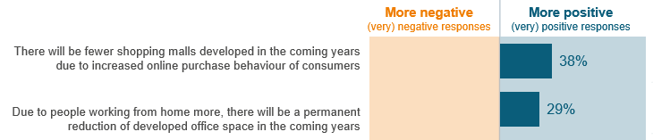

European Architectural Barometer Q1 2021 – USP Marketing Consultancy

About USP Marketing Consultancy
USP Marketing Consultancy is a leading international market research agency that is specialized in the construction, installation and DIY sector for over 25 years. USP Marketing Consultancy works for internationally renowned companies, such as AkzoNobel, Philips, Grohe, Forbo, etc. Our clients often have pan-European questions about their brand awareness, customer journeys, market opportunities, e-commerce trends and other research needs. USP Marketing Consultancy delivers the insights to make decisions and acts as a marketing advisor for its clients.

Noot for editors
For more information, please contact Jeroen de Gruijl of USP Marketing Consultancy, via + 31 6 83979041 or deGruijl@usp-mc.nl

When you publish (parts of) this press release, we would like to receive a copy. Please send it to:
USP Marketing Consultancy
Jeroen de Gruijl
Max Euwelaan 51
3062 MA Rotterdam
deGruijl@usp-mc.nl

